3.1-3.4 Mini Quiz: Reading & Interpreting Histograms

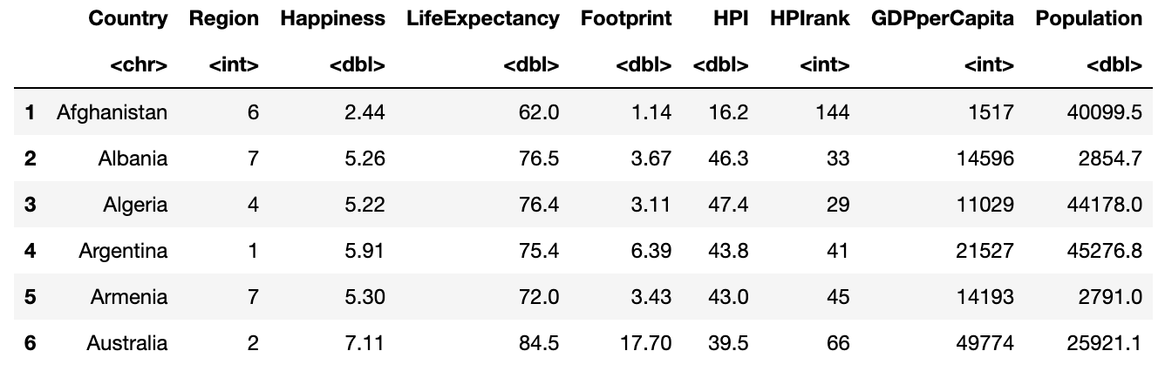
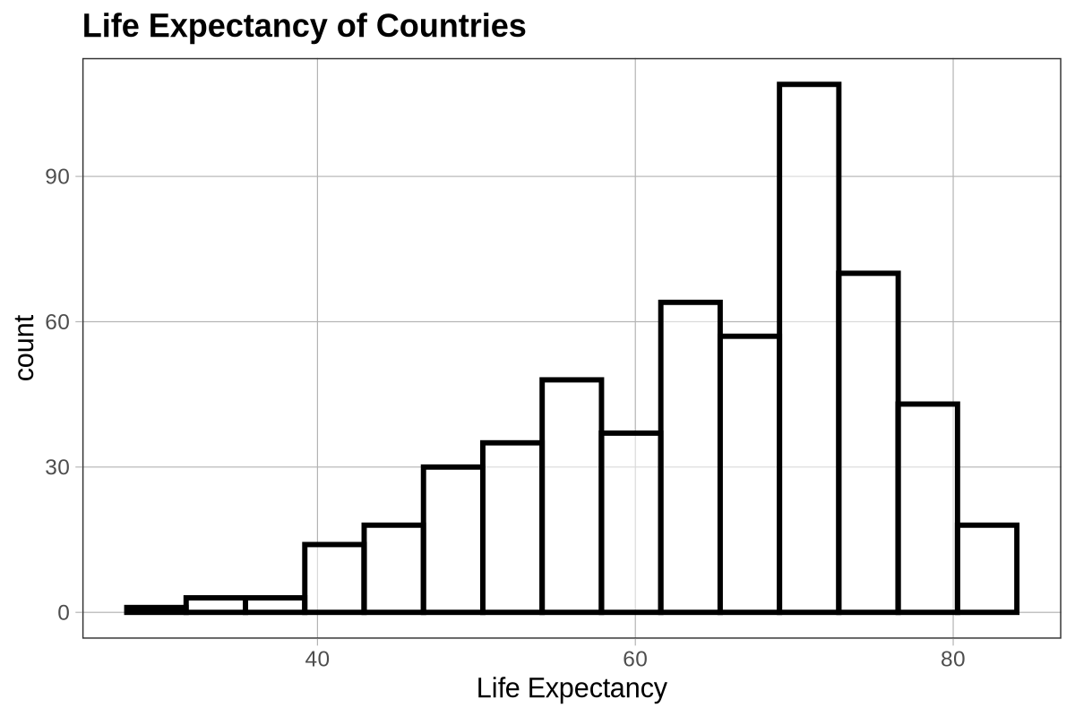
A student is learning how to read histograms and used a sample from the Gapminder data on life expectancy (in years) for countries around the world. They created a histogram to better understand the distribution and now need guidance interpreting different parts of the graph. Help describe some of its key features.

- What does the x-axis represent in this histogram?

- What does the y-axis represent in this histogram?

- What does the shortest bar on the histogram tell you?

- What does the tallest bar on the histogram tell you?

- If we added a country with a mean life expectancy of 30 years to this data, where would it show up on the histogram? Use an arrow or circle to show where it belongs.

